Lecture 3

AWS-Services Overview-Billing-Support Center-Waive off

* Amazon is increasing the nos of Regions across the globe
* Similarly AZs are also increasing
* 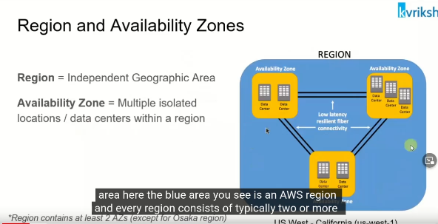
* One account can access all regions.
* Diagram

  Description automatically generated
* AWS services
* 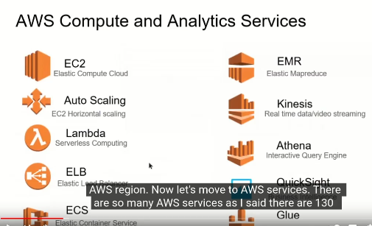
* .
* 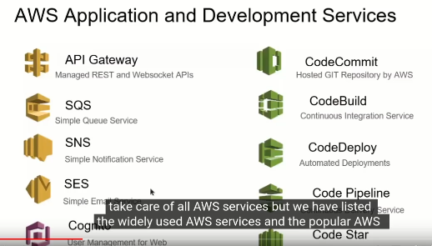
* These all services are important, and we are going to learn very soon **InnSha Allah**
  + These services are already being used in industry by AWS has renamed it accordingly in cloud environment.
  + 80% services are same in on-prem and cloud.
* 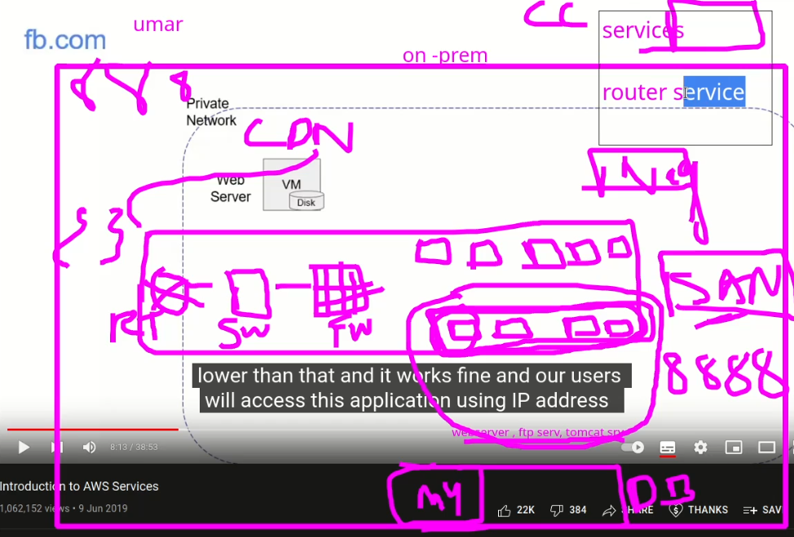
* These all services are available in AWS Dashboard.
* 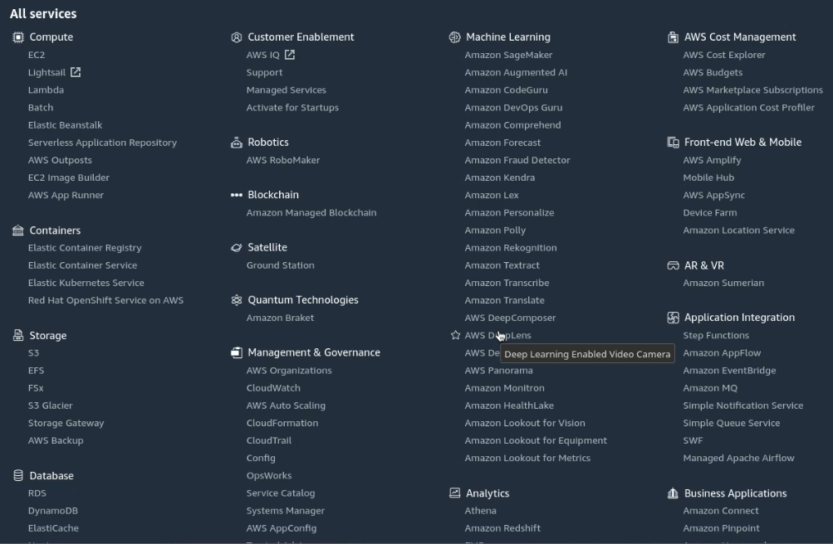
* On-prem (Private Network) example of a typical work example in industry
* 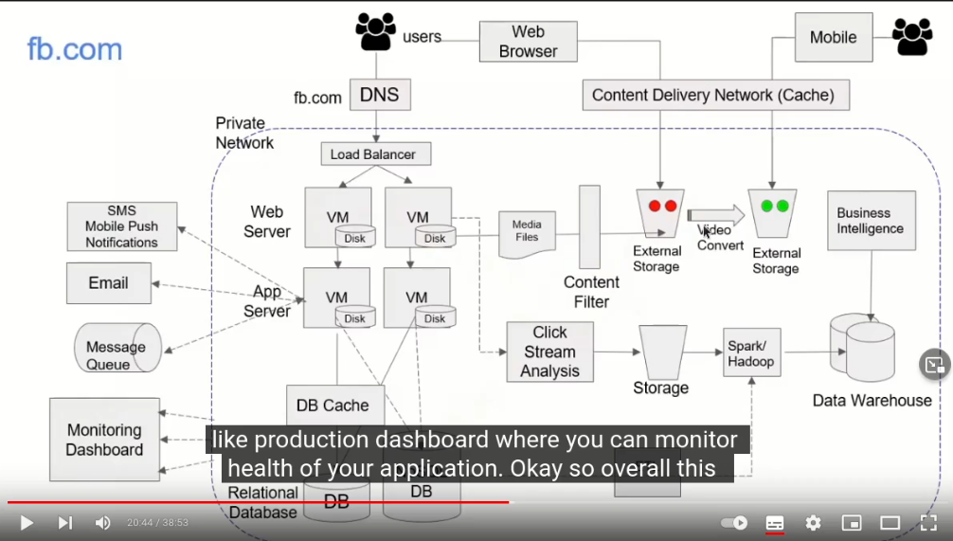
* In cloud it is called VPC (Virtual Private Cloud)
* 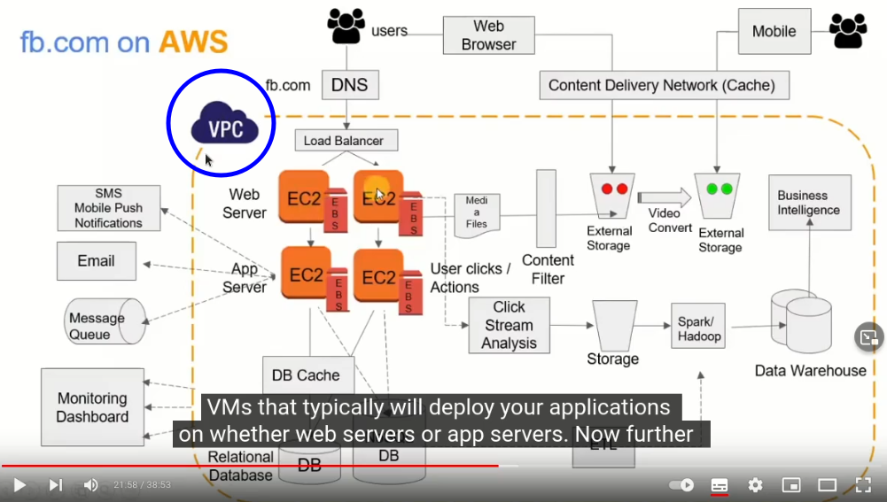
* Private Network
* Diagram

  Description automatically generated
* VPC
* 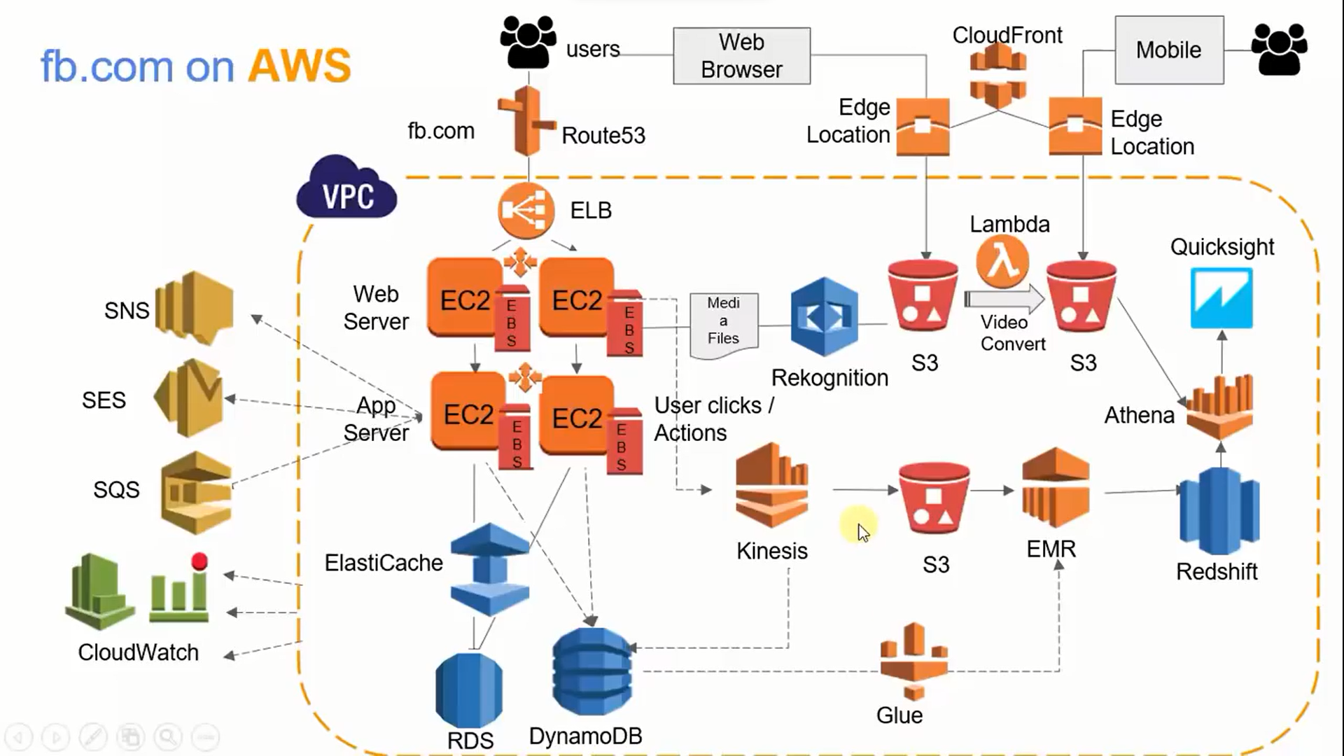
* AWS Security Services
* 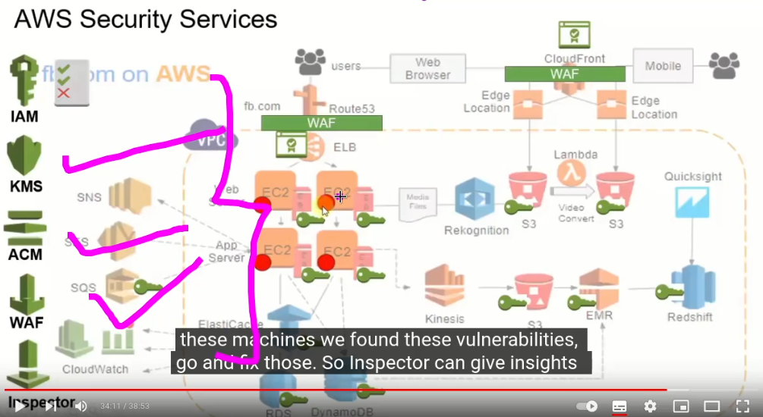
* AWS Automation
* 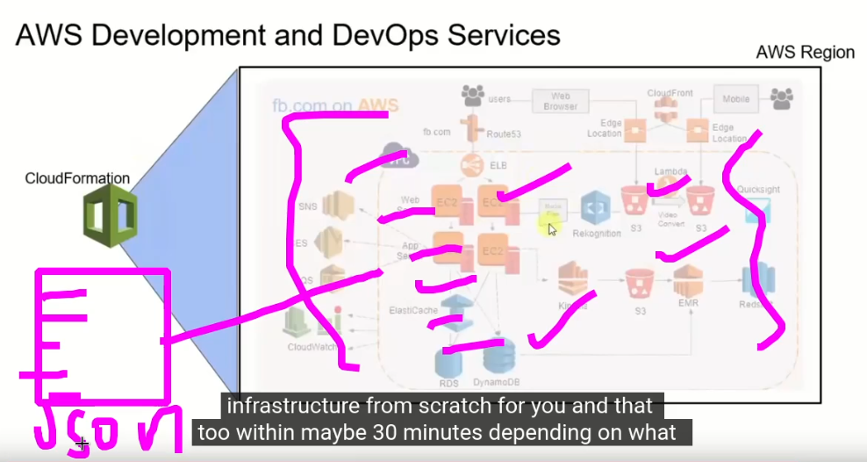

**Tip: - it happens rarely but few services are region dependent.**